ABC’s Inventory Management System

Login Test Scripts

Table of Contents

LIT001- Log in using ‘Warehouse Staff’ username that exists and password that matches 3

Data Set 1 3

Result Screenshots: 3

LIT002- Log in using ‘Warehouse Staff’ username that exists and password that does not match 5

Data Set 1 6

Result Screenshots: 6

LIT003- Log in using ‘Store Staff’ username that exists and password that matches 8

Data Set 1 8

Result Screenshots: 8

LIT004- Log in using ‘Store Staff’ username that exists and password that does not match 10

Data Set 1 11

Result Screenshots: 11

LIT005- Log in using a random username and password that does not exist 13

Data Set 1 13

Result Screenshots: 13

LIT006- Click on ‘Clear Text’ icon 15

Data Set 1 16

Result Screenshots: 16

# LIT001- Log in using ‘Warehouse Staff’ username that exists and password that matches

|  |  |  |  |  |  |
| --- | --- | --- | --- | --- | --- |
| **Test Name** | | Test log in using ‘Warehouse Staff’ username that exists and password that matches (Test LIT001) | | | |
| **Use Case Tested** | | Login/ Logout | | | |
| **Test Description** | | This test tests if the system can grant access to a Warehouse Staff using their username and password | | | |
| **Pre-Conditions** | | Device must be connected to the internet. | | | |
| **Post-Conditions** | | User is granted access and homepage is displayed without any restrictions. | | | |
| **Result (Pass/Fail/Warning/ Incomplete)** | | Pass | | | |
|  | **Test Step** | | **Expected Test Results** | **P** | **F** |
| 1. | User launches the ‘ABC Inventory’ application. | | System is launched, and the login page is displayed. | P |  |
| 2. | Enter Warehouse Staff username and password that match. | | System waits until the user clicks on the ‘Login’ button. | P |  |
| 3. | Click on ‘Login’ icon. | | System grants access to the user and displays the Homepage of the system without any restrictions. | P |  |

## Data Set 1

|  |  |
| --- | --- |
| **Data Set 1** | |
| **Field** | **Values** |
| **Username** | shirish |
| **Password** | shirish |

### Result Screenshots:

**Step 1**

System is launched after which Login Page is displayed.

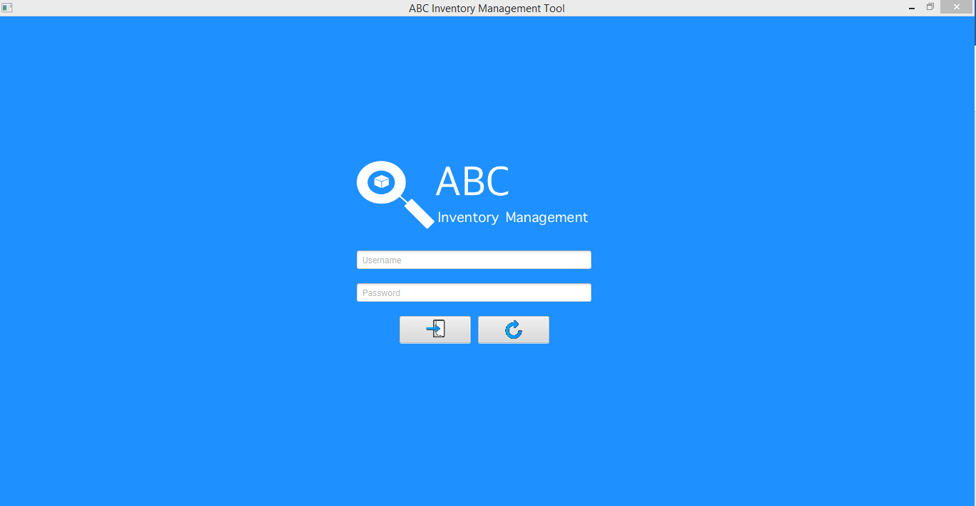

**Step 2**

Enter warehouse staff username and password that match.

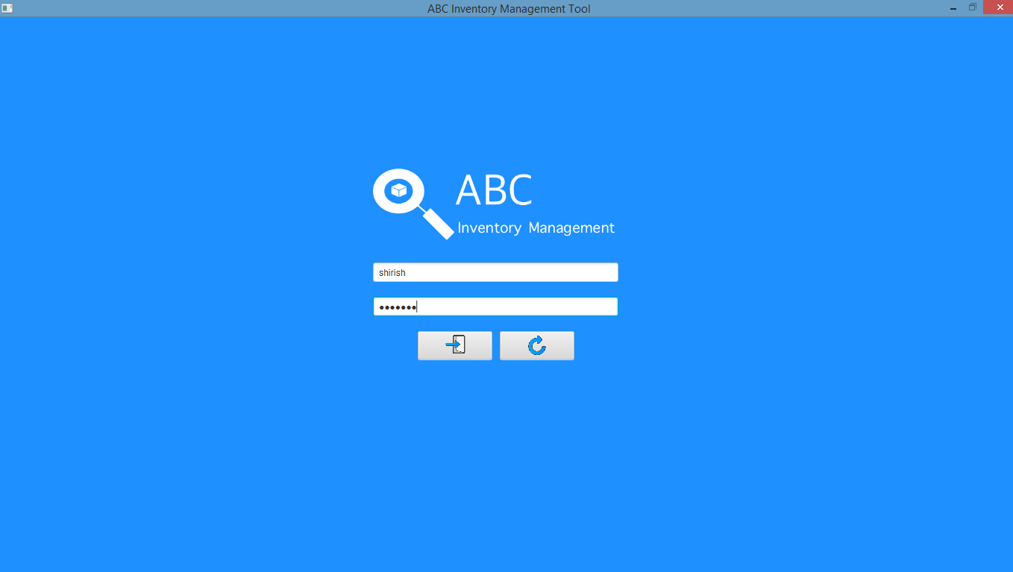

**Step 3**

Access is granted, and home page is displayed without any restrictions.

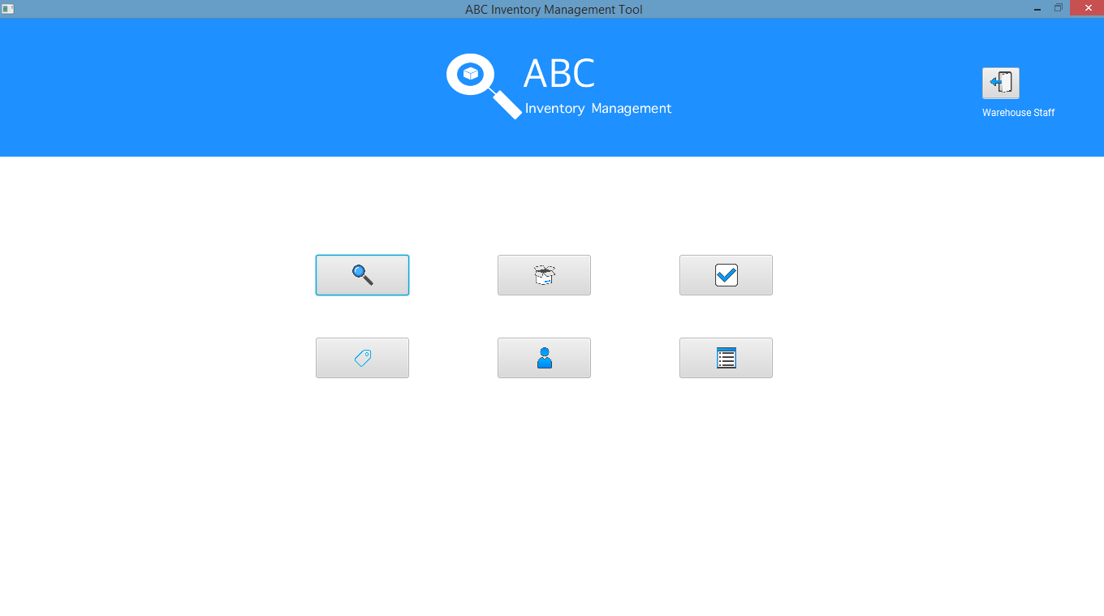

# LIT002- Log in using ‘Warehouse Staff’ username that exists and password that does not match

|  |  |  |  |  |  |
| --- | --- | --- | --- | --- | --- |
| **Test Name** | | Test log in using ‘Warehouse Staff’ username that exists and password that does not match (Test LIT002) | | | |
| **Use Case Tested** | | Login/ Logout | | | |
| **Test Description** | | This test tests how the system reacts when the password for the warehouse staff username entered is incorrect. | | | |
| **Pre-Conditions** | | Device must be connected to the internet. | | | |
| **Post-Conditions** | | User is denied access and an error message is displayed. | | | |
| **Result (Pass/Fail/Warning/ Incomplete)** | | Pass | | | |
|  | **Test Step** | | **Expected Test Results** | **P** | **F** |
| 1. | User launches the ‘ABC Inventory’ application. | | System is launched, and the login page is displayed. | P |  |
| 2. | Enter Warehouse Staff username and password that is incorrect. | | System waits until the user clicks on the ‘Login’ button. | P |  |
| 3. | Click on ‘Login’ icon. | | Access is denied, and an error message is displayed. | P |  |

## Data Set 1

|  |  |
| --- | --- |
| **Data Set 1** | |
| **Field** | **Values** |
| **Username** | shirish |
| **Password** | abcd |

### Result Screenshots:

**Step 1**

System is launched after which Login Page is displayed.



**Step 2**

Enter warehouse staff username and password that is incorrect.

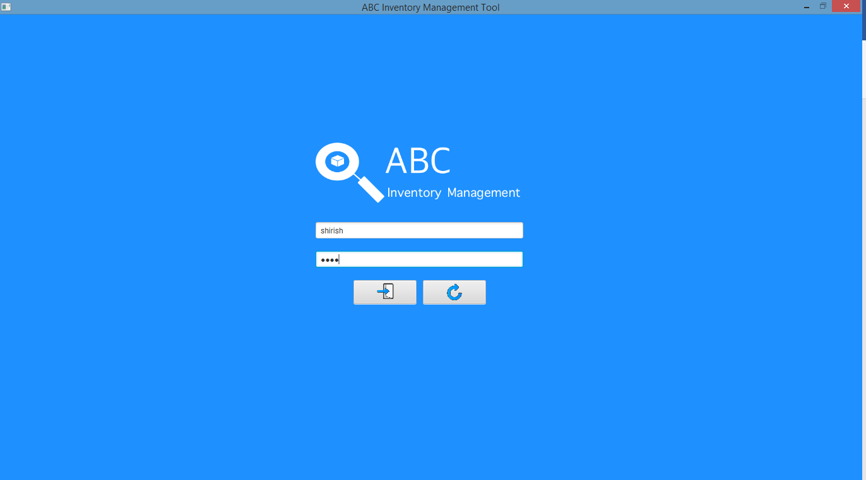

**Step 3**

Access is denied, and an error message is displayed.

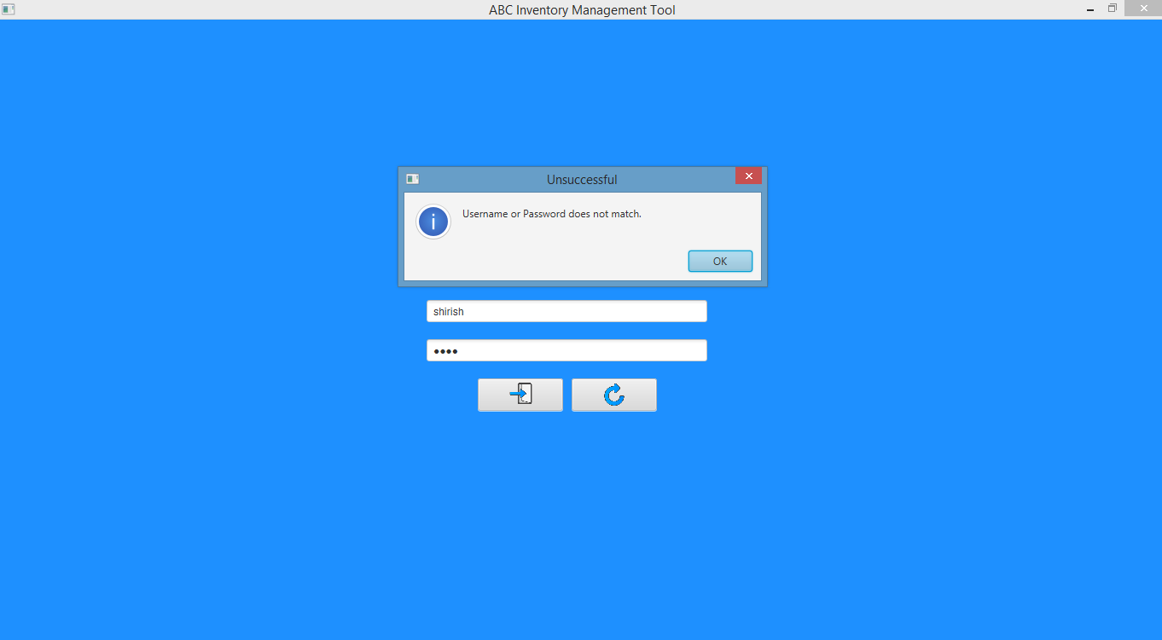

# LIT003- Log in using ‘Store Staff’ username that exists and password that matches

|  |  |  |  |  |  |
| --- | --- | --- | --- | --- | --- |
| **Test Name** | | Test log in using ‘Store Staff’ username that exists and password that matches (Test LIT003) | | | |
| **Use Case Tested** | | Login/ Logout | | | |
| **Test Description** | | This test tests if the system can grant access to a Store Staff using their username and password | | | |
| **Pre-Conditions** | | Device must be connected to the internet. | | | |
| **Post-Conditions** | | User is granted access and homepage is displayed.  Manage Staff and Manage Product Icons are disable (Restrictions applied). | | | |
| **Result (Pass/Fail/Warning/ Incomplete)** | | Pass | | | |
|  | **Test Step** | | **Expected Test Results** | **P** | **F** |
| 1. | User launches the ‘ABC Inventory’ application. | | System is launched, and the login page is displayed. | P |  |
| 2. | Enter Store Staff username and password that match. | | System waits until the user clicks on the ‘Login’ button. | P |  |
| 3. | Click on ‘Login’ icon. | | System grants access to the user and displays the Homepage of the system with restrictions (Manage Staff and Manage Product icons are disabled) | P |  |

## Data Set 1

|  |  |
| --- | --- |
| **Data Set 1** | |
| **Field** | **Values** |
| **Username** | peter |
| **Password** | peter |

### Result Screenshots:

**Step 1**

System is launched after which Login Page is displayed.



**Step 2**

Enter store staff username and password that match.

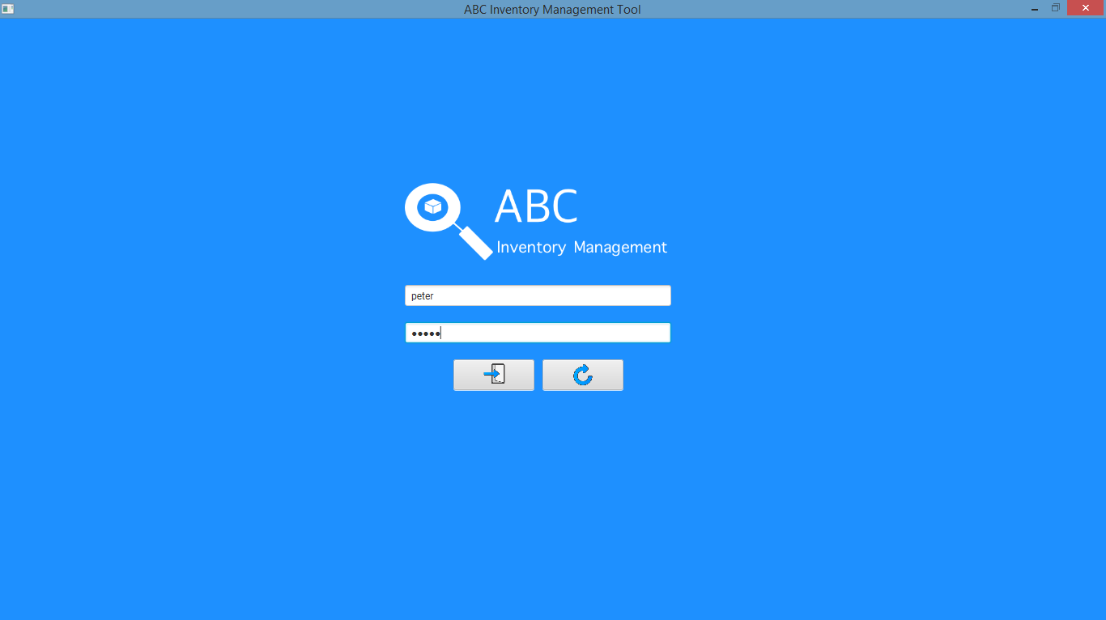

**Step 3**

Access is granted, and home page is displayed with restrictions (Manage Staff and Manage Product icons are disabled)

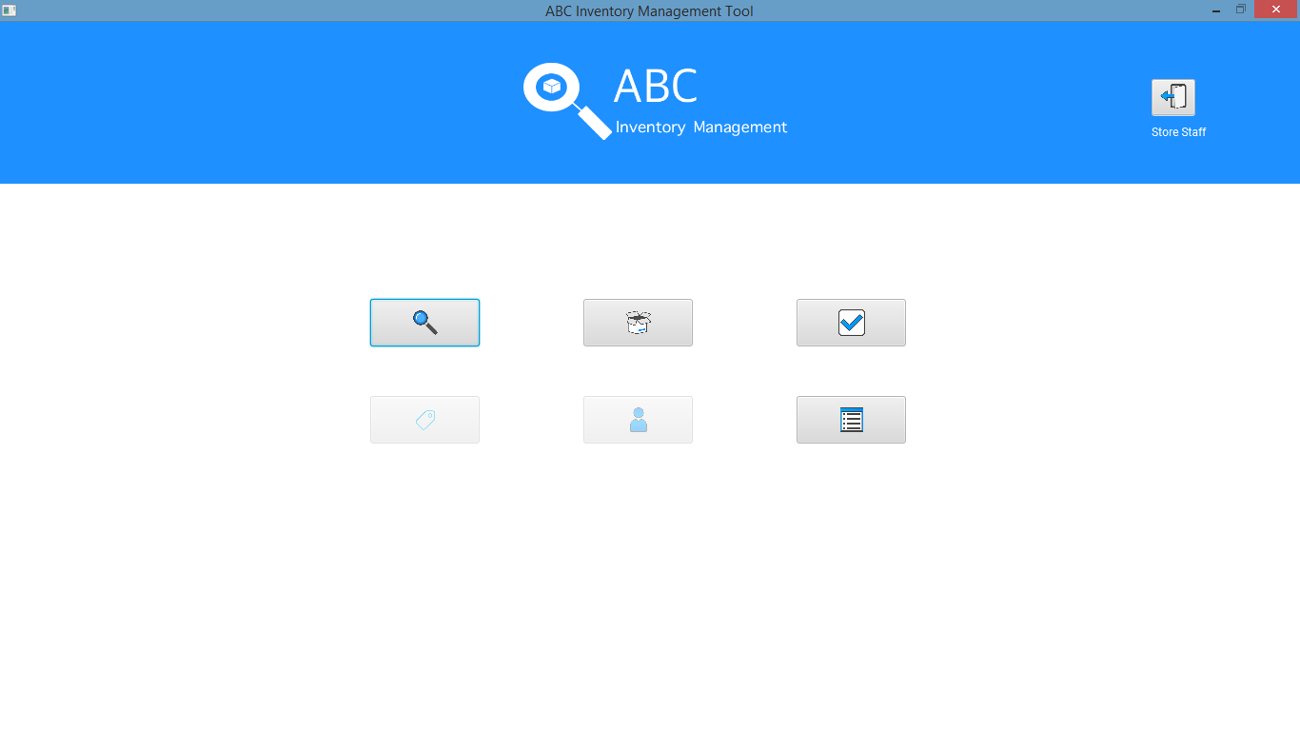

# LIT004- Log in using ‘Store Staff’ username that exists and password that does not match

|  |  |  |  |  |  |
| --- | --- | --- | --- | --- | --- |
| **Test Name** | | Test log in using ‘Store Staff’ username that exists and password that does not match (Test LIT004) | | | |
| **Use Case Tested** | | Login/ Logout | | | |
| **Test Description** | | This test tests how the system reacts when the password for the store staff username entered is incorrect. | | | |
| **Pre-Conditions** | | Device must be connected to the internet. | | | |
| **Post-Conditions** | | User is denied access and an error message is displayed. | | | |
| **Result (Pass/Fail/Warning/ Incomplete)** | | Pass | | | |
|  | **Test Step** | | **Expected Test Results** | **P** | **F** |
| 1. | User launches the ‘ABC Inventory’ application. | | System is launched, and the login page is displayed. | P |  |
| 2. | Enter Store Staff username and password that is incorrect. | | System waits until the user clicks on the ‘Login’ button. | P |  |
| 3. | Click on ‘Login’ icon. | | Access is denied, and an error message is displayed. | P |  |

## Data Set 1

|  |  |
| --- | --- |
| **Data Set 1** | |
| **Field** | **Values** |
| **Username** | peter |
| **Password** | abcd |

### Result Screenshots:

**Step 1**

System is launched after which Login Page is displayed.



**Step 2**

Enter store staff username and password that is incorrect.

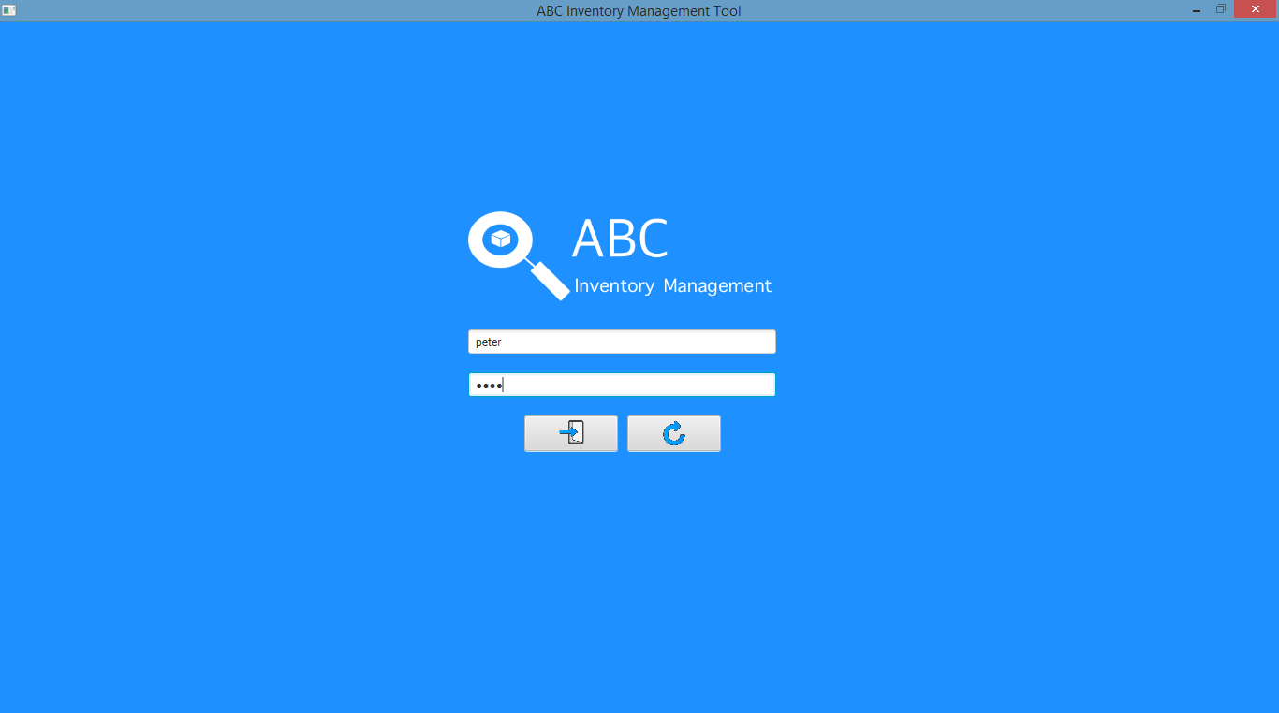

**Step 3**

Access is denied, and an error message is displayed.

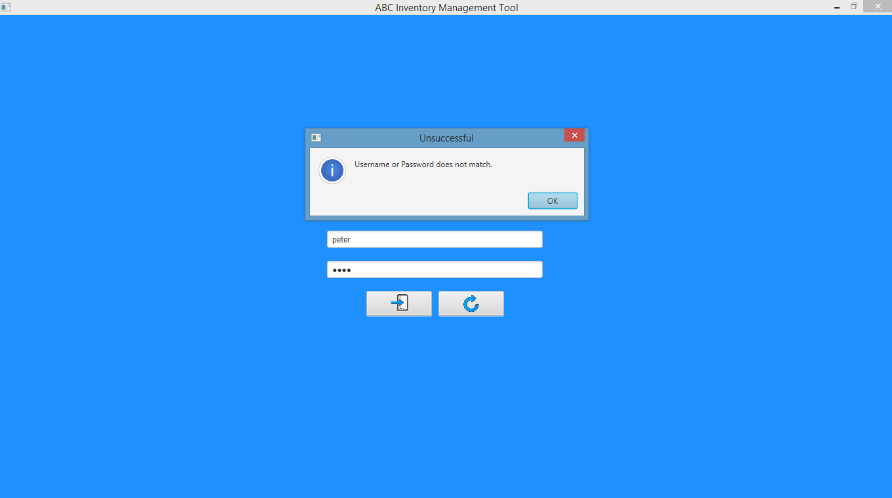

# LIT005- Log in using a random username and password that does not exist

|  |  |  |  |  |  |
| --- | --- | --- | --- | --- | --- |
| **Test Name** | | Test log in using a random username and password that does not exist (Test LIT005) | | | |
| **Use Case Tested** | | Login/ Logout | | | |
| **Test Description** | | This test tests how the system reacts when a random username and password that does not exist in the database is entered. | | | |
| **Pre-Conditions** | | Device must be connected to the internet. | | | |
| **Post-Conditions** | | User is denied access and an error message is displayed. | | | |
| **Result (Pass/Fail/Warning/ Incomplete)** | | Pass | | | |
|  | **Test Step** | | **Expected Test Results** | **P** | **F** |
| 1. | User launches the ‘ABC Inventory’ application. | | System is launched, and the login page is displayed. | P |  |
| 2. | Enter random username and password that does not exist in the database. | | System waits until the user clicks on the ‘Login’ button. | P |  |
| 3. | Click on ‘Login’ icon. | | Access is denied, and an error message is displayed. | P |  |

## Data Set 1

|  |  |
| --- | --- |
| **Data Set 1** | |
| **Field** | **Values** |
| **Username** | bekkie |
| **Password** | bekkie |

### Result Screenshots:

**Step 1**

System is launched after which Login Page is displayed.



**Step 2**

Enter random username and password that does not exist in the database.

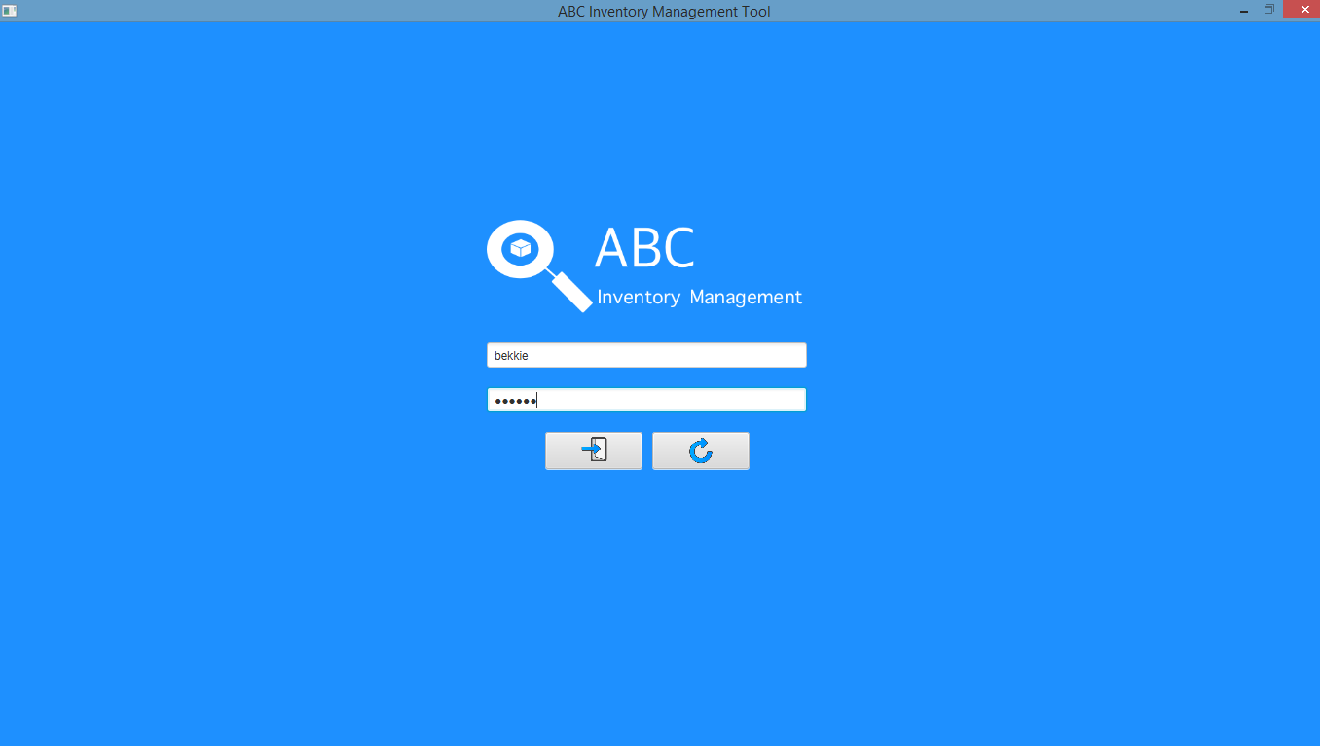

**Step 3**

Access is denied, and an error message is displayed.

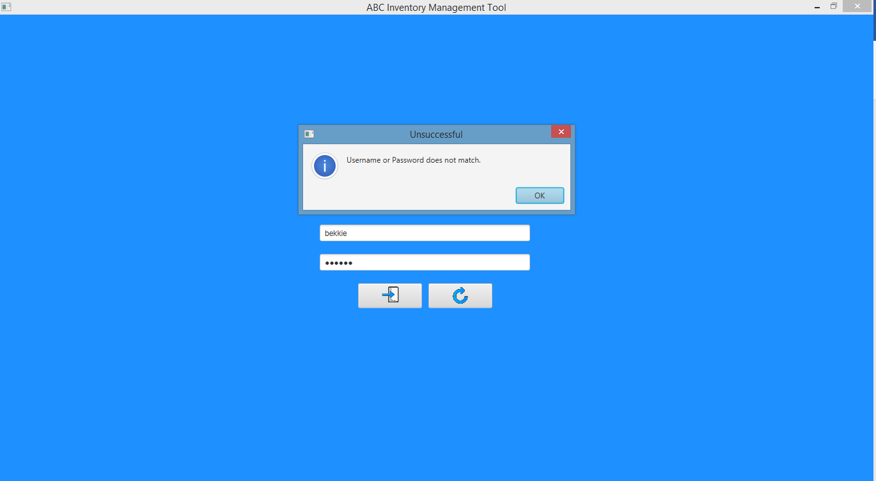

# LIT006- Click on ‘Clear Text’ icon

|  |  |  |  |  |  |
| --- | --- | --- | --- | --- | --- |
| **Test Name** | | Test click on ‘Clear Text’ icon (Test LIT006) | | | |
| **Use Case Tested** | | Login/ Logout | | | |
| **Test Description** | | This test tests how the system reacts when the user clicks on the ‘Clear Text’ icon. | | | |
| **Pre-Conditions** | | Device must be connected to the internet. | | | |
| **Post-Conditions** | | Entered values are cleared. | | | |
| **Result (Pass/Fail/Warning/ Incomplete)** | | Pass | | | |
|  | **Test Step** | | **Expected Test Results** | **P** | **F** |
| 1. | User launches the ‘ABC Inventory’ application. | | System is launched, and the login page is displayed. | P |  |
| 2. | Enter username and password. | | System waits until the user clicks on the ‘Login’ button. | P |  |
| 3. | Click on ‘Clear Text’ icon. | | Entered username and password values are cleared. | P |  |

## Data Set 1

|  |  |
| --- | --- |
| **Data Set 1** | |
| **Field** | **Values** |
| **Username** | shirish |
| **Password** | shirish |

### Result Screenshots:

**Step 1**

System is launched after which Login Page is displayed.



**Step 2**

Enter username and password.

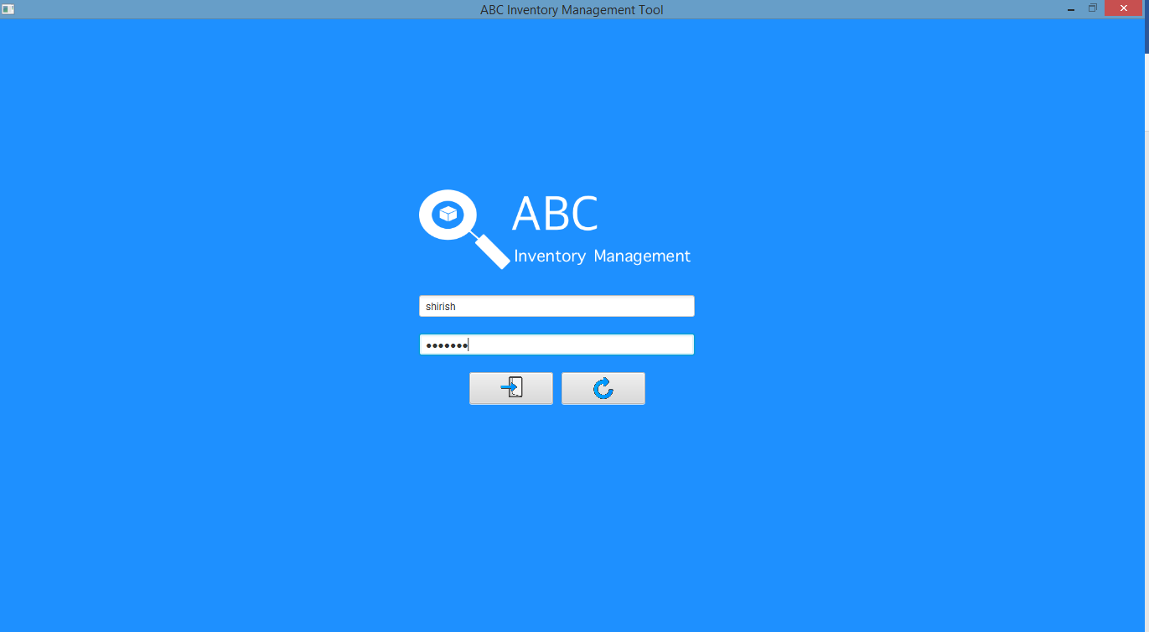

**Step 3**

After clicking on ‘Clear Text’ icon.

